Problem no 01: “Positive or negative”
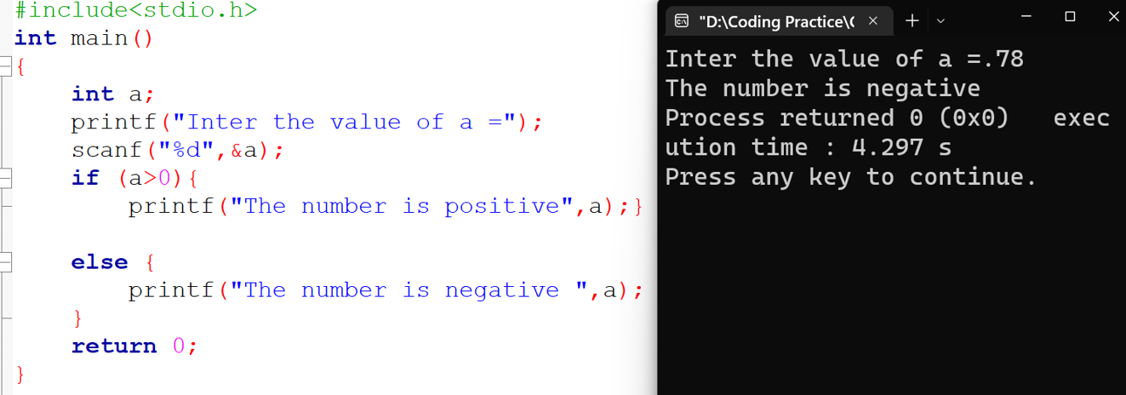
input: output:
Description: I use if -else condition with variable a . Then printed the number positive or negative.
Problem no 02: “Even or odd”
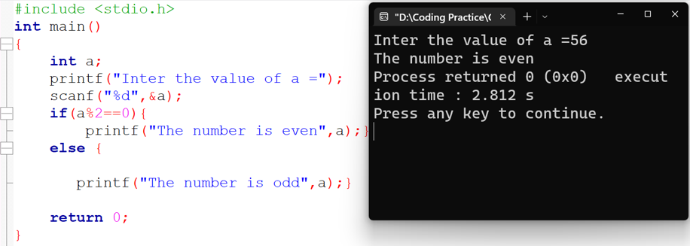
input: output:
Description:

Problem no 03: Swapping ( using 3rd variable)
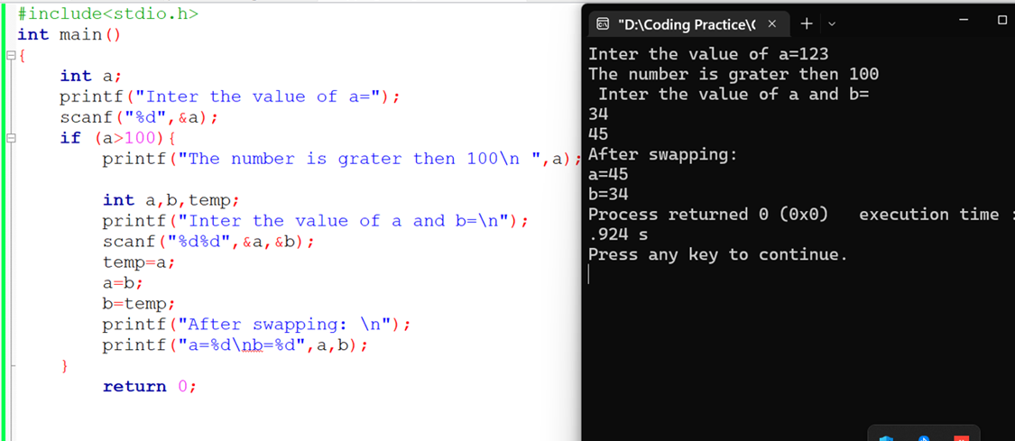
Input: output:
Description: we learn swapping.using 3rd variable temp.

Problem on 04: Swapping (without using 3rd variable)
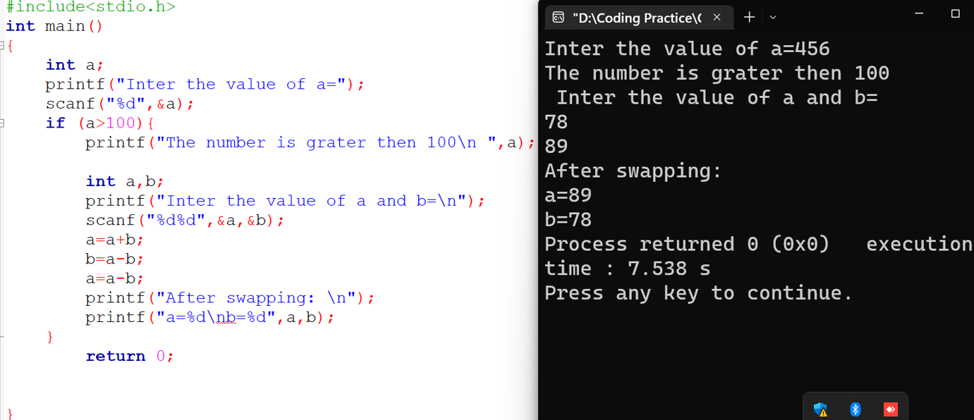
input: output:
Problem no 05: Condition (a==b)(a>b)(a<b)
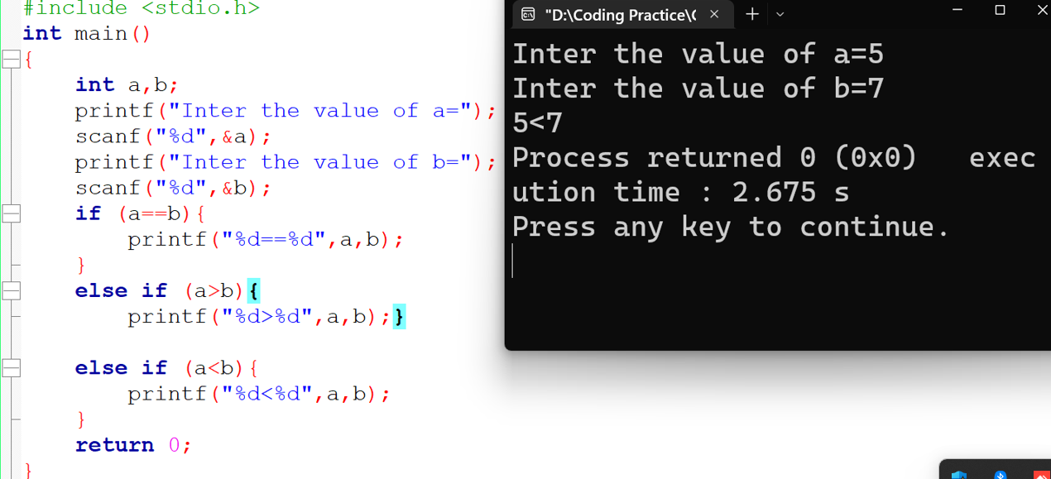
Input: output:

Conclusion: we learn how to use “ else if”

Problem no 06: condition Using( “&&” “||” “ !”)
Input: output:
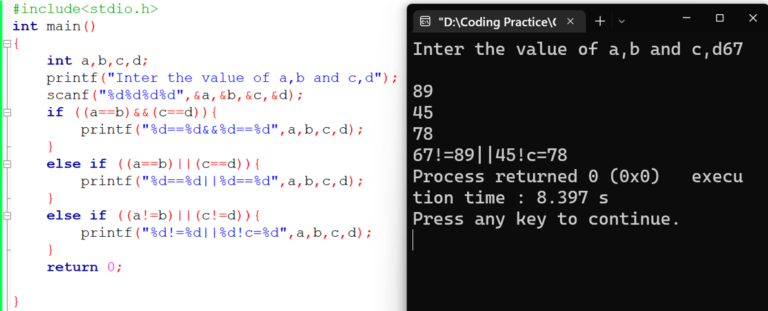

Bangladesh University of Business & Technology



Lab Report: 04
Course Title: Structured Programming Language Lab Code: CSE-112

Submitted By | Submitted To
Name: Rakibul Islam Asif  ID: 22235103319  Intake:51, Section:8 Department of CSE | Name: Md. Saddam Hossain.  Assistant Professor  Department of CSE BUBT

